COVID Screening Automatic Door

COVIDoor (Team 93)

Sean Hwang, Seojune Jung, Jungun Kim, Natt Towiwat, Hayley Yoo

Design Document - Rev. 1

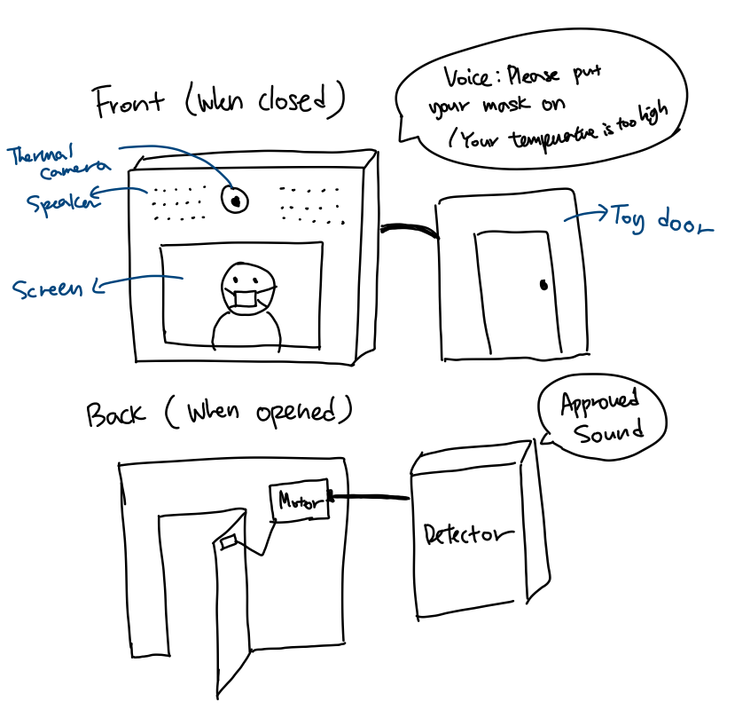

*Figure 0.1: Product Sketch*

**TA :** Sayan Roy

**Professor** : Prof. Peter Bermel, Prof. Arif Ghafoor

Contents

**List of Figures**

Figure 0.1 1

Figure 3.19

Figure 3.210

**List of Tables**

Table 0.13

**Revision Log 4**

**Glossary 5**

**1 Introduction 6**

1.1 Executive Description 6

1.2 User Story 6

**2 Design Requirements 7**

2.1 Requirements 7

2.2 Factors influencing requirements 7,8

**3 System Overview** 9

3.1 System Block Diagram 9

3.2 System Activity Diagram 10

**4 Team Structure 1**1

**Bibliography 12**

# List of Figures

0.1 Product Sketch 1

3.1 System Block Diagram 9

3.2 System Activity Diagram 10

# List of Tables

0.1 Revision Log 4

# Revision Log

|  |  |  |
| --- | --- | --- |
| **Date** | **Revision** | **Changes** |
| 1/30/2021 | 1 | * First draft created |

*Table 0.1: Revision Log*

# Glossary

**CPU/GPU:** processor acts as the operations center of a computer./specialized processor originally designed to accelerate graphics rendering. [1]

**Deep Learning:** a subfield of machine learning concerned with algorithms inspired by the structure and function of the brain called artificial neural networks. [2]

**Image recognition:** the pixel and pattern analysis of an image to recognize the image as a particular object. [3]

**Infrared Sensors:** an electronic device that measures and detects infrared radiation in its surrounding environment. [4]

**OpenCV:** the huge open-source library for computer vision, machine learning, and image processing and now it plays a major role in real-time operation which is very important in today’s systems. [5]

**Raspberry Pi:** the name of a series of single-board computers made by the [Raspberry Pi Foundation](https://www.raspberrypi.org/about/). The primary CPU board that this project will be built on. [6]

**Servo Motor:** a simple electric motor, controlled with the help of servomechanism. [7]

**Neural network:** a series of algorithms that endeavors to recognize underlying relationships in a set of data through a process that mimics the way the human brain operates. [8]

**Tensorflow:** Open source software platform for machine learning equipped with a comprehensive, flexible ecosystem of tools, libraries, and community resources for machine learning developers. [9]

# 1 Introduction

## Executive Description

The main purpose of COVIDoor’s COVID screening automatic door is to ‘screen’ the potential spreading of this highly contagious virus in populated buildings by only granting access to those with a face mask on and has a normal temperature. The system will utilize an infrared sensor that measures the user’s temperature, as well as a camera that is pre-trained to detect a mask. The CPU will be programmed to take in the data from the infrared sensor and the camera and make a decision whether to open the door or not. Finally, the system will have an automatic door module that is controlled automatically by the CPU, which will allow access to those who pass the screening process.

## User Story

Studies have shown that wearing a face mask can reduce the spreading of ongoing COVID-19 viruses by ***65 percent* [10]*.*** However, there still are many people who forget - or choose not - to wear a face mask in a public area. Wearing a facemask is especially important in highly populated buildings or areas such as malls, schools, airports, hospitals, etc; yet enforcement of such action is not done properly in most of these areas. The primary goal of this project is to build an automatic door that screens people’s temperature as well as wearing a face mask. The door will only open to those with a mask on, with a normal temperature. It will remind those without a mask on to wear one and will not open until they do have a mask put on. Those with a high temperature will be warned and will be advised to stay home and seek medical professionals.

# 2 Design Requirements

## Requirements

* + 1. Must differentiate a face with a mask on to those without a mask on.
    2. Must accurately measure a person’s temperature.
    3. Must automatically decide whether to open the door or not.
    4. Must have a working automatic door controlled by the system.

## Factors influencing requirements

* + 1. Public Health, Safety and Welfare
       1. Wearing masks can reduce the infection in indoor environments. [11]
       2. Since high fever is one of the most common symptoms of COVID-19 [12], Checking temperature can prevent one’s entering who are suspected of infection.
    2. Global Factors
       1. COVID19 is an ongoing worldwide pandemic that globally damages the economy.[13]
       2. There are still many people travelling around the world and confirmed cases after entering the country.[14] Checking for masks and temperature before entering the airport will reduce the infection from different countries.
    3. Cultural Factors
       1. Different people of ethnicity (in respect to different nations) will have different types of face genetics. This can affect the angle of wearing masks, in respect to the face detector.
       2. By not letting one in the buildings unless they wear masks, the habit and public awareness of wearing masks can be established.
    4. Social Factors
       1. Some individuals are not aware of the seriousness of COVID-19 and refuse to wear face masks. However, since the disease can be deadly, the priority should be to prevent it from spreading by masks.
       2. Some people claim, ‘wearing a mask violates freedom’.
    5. Environmental Factors
       1. The disease can be contagious to animals and can be transformed.[15] This machine will reduce spreading the disease which will decrease the chance of animals getting infected.
       2. For businesses, many states require customers to wear face masks in stores.[16] If a person distinguishes people wearing masks, there will be much use of cleaning tools. This machine will not only save employees but also reduce waste.
    6. Economic Factors
       1. Reduce unnecessary manpower consumption that checks for masks and temperature.
       2. By thoroughly inspecting masks and checking temperatures, more people will feel safe and visit the workplace more often.

# 

# 3 System Overview

## 3.1 System Block Diagram

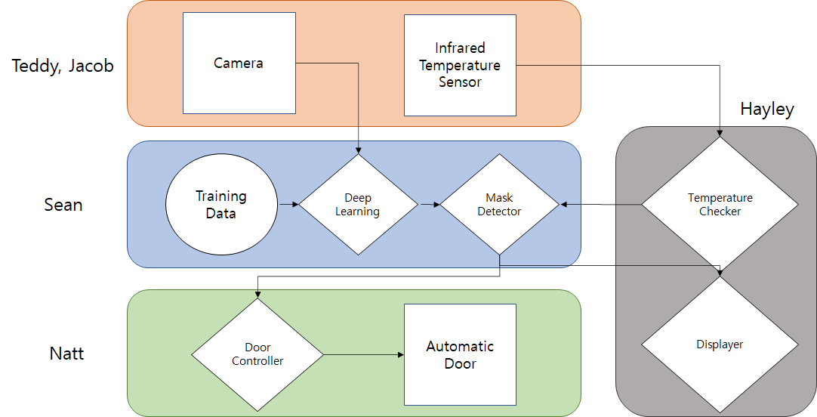

*Figure 3.1: System level UML2 Block Diagram*

## 3.2 System Activity Diagram

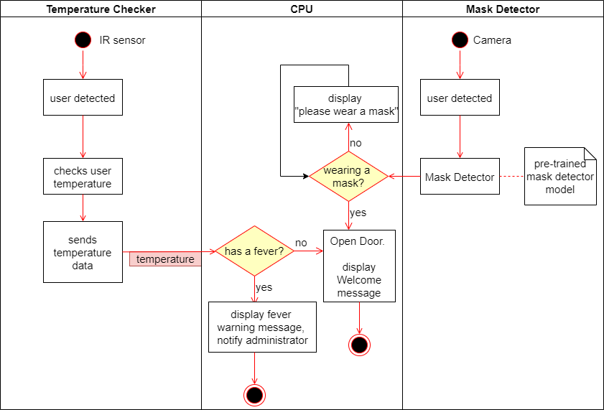

*Figure 3.2: System level UML2 Activity Diagram*

# 

# 4 Team Structure

**Sean Hwang:**

Degree program: 4+1 BS/MS ECE.

Project background: 3xPurdue VIP, EPICS, USB 1.1 Receiver ASIC (ECE337), Microcontroller project (ECE 362), Digital signal processing (ECE 538).

Individual skills: Machine learning, computer vision, programming.

**Seojung Jung:**

Degree program: BS in Electrical Engineering

Project background: Purdue VIP, EPICS, FPGA, Image processing using MATLAB, Digital Signal Processing(ECE 538),

Individual skills: MATLAB, Python, C, Circuit Building

**Teddy Kim:**

Degree program: BS in Electrical Engineering

Project background: Purdue VIP, EPICS, Image processing with MATLAB, Building automatic door closing system with Arduino

Individual Skills: Verilog, C, Circuit building

**Natt Towiwat:**

Degree program: BS in Electrical Engineering (Minor in Physics and Applied Mathematics)

Project background: PID controller with Simulink MATLAB, RaspberryPi with LED lights

Individual Skills: Python, MATLAB programming, Machine Learning, Deep Learning,, Optimization (Theory)

**Hayley Yoo:**

Degree program: BS in Computer Engineering

Project background: Microcontroller project (ECE 362), C++ Rogue game project (ECE39595), Huffman coding (ECE 368)

Individual skills: Programming, data structure, embedded system.

# Bibliography

1. Difference between CPU and GPU. (2020, July 07). Retrieved January 30, 2021, from <https://www.geeksforgeeks.org/difference-between-cpu-and-gpu/>
2. Brownlee, J. (2020, August 14). What is Deep Learning? Retrieved January 30, 2021, from <https://machinelearningmastery.com/what-is-deep-learning/>
3. Dataman, D. (2020, December 07). What Is Image Recognition? Retrieved January 30, 2021, from <https://towardsdatascience.com/module-6-image-recognition-for-insurance-claim-handling-part-i-a338d16c9de0>
4. Jost, D. (2019, July 30). What is an IR sensor? Retrieved January 30, 2021, from <https://www.fierceelectronics.com/sensors/what-ir-sensor>
5. OpenCV - Overview. (2019, October 03). Retrieved January 30, 2021, from [https://www.geeksforgeeks.org/opencv-overview](https://www.geeksforgeeks.org/opencv-overview/)
6. What is a Raspberry Pi? (n.d.). Retrieved January 30, 2021, from <https://opensource.com/resources/raspberry-pi>
7. Electrical4U. (2020, October 28). What is a Servomotor? Retrieved January 30, 2021, from <https://www.electrical4u.com/what-is-servo-motor/>
8. Chen, J. (2020, December 23). Neural Network Definition. Retrieved January 30, 2021, from <https://www.investopedia.com/terms/n/neuralnetwork.asp>
9. Tensorflow. (n.d.). Tensorflow/tensorflow. Retrieved January 30, 2021, from <https://github.com/tensorflow/tensorflow>
10. Staff, D., Fell, A., & Kushman, R. (2020, October 28). Your Mask Cuts Own Risk by 65 Percent. Retrieved January 30, 2021, from <https://www.ucdavis.edu/coronavirus/news/your-mask-cuts-own-risk-65-percent>
11. Miller, K. (2020, December 07). WHO Recommends Wearing a Mask Inside Buildings With Poor Ventilation. Retrieved January 30, 2021, from <https://www.verywellhealth.com/who-wear-a-mask-indoors-poor-ventilation-5090273>
12. Coronavirus disease (COVID-19). (n.d.). Retrieved January 30, 2021, from <https://www.who.int/emergencies/diseases/novel-coronavirus-2019/question-and-answers-hub/q-a-detail/coronavirus-disease-covid-19#:~:text=symptoms>
13. The Global Economic Outlook During the COVID-19 Pandemic: A Changed World. (n.d.). Retrieved January 30, 2021, from <https://www.worldbank.org/en/news/feature/2020/06/08/the-global-economic-outlook-during-the-covid-19-pandemic-a-changed-world>
14. Sampson, H., & McMahon, S. (2020, December 28). People with coronavirus are still getting on planes. No one knows how many. Retrieved January 30, 2021, from <https://www.washingtonpost.com/travel/2020/12/28/passenger-covid-flight-airlines-positive/>
15. If You Have Pets. (n.d.). Retrieved January 30, 2021, from <https://www.cdc.gov/coronavirus/2019-ncov/daily-life-coping/pets.html>
16. Markowitz, A. (n.d.). Does Your State Have a Mask Mandate Due to Coronavirus? Retrieved January 30, 2021, from [https://www.aarp.org/health/healthy-living/info-2020/states-mask-mandates-coronavirus.htm](https://www.aarp.org/health/healthy-living/info-2020/states-mask-mandates-coronavirus.html)